Benefits Claims Decision Support System (BCDSS)

User Manual



**February 2017**

Version 1.1

Department of Veterans Affairs

Revision History

|  |  |  |  |  |
| --- | --- | --- | --- | --- |
| **Date** | **Version** | **Description** | **Author** | **Reviewer(s)** |
| 2017-15/02 | 1.1 | Added [Detailed Analysis Report(s) for the Model Result(s)](#_Detailed_Analysis_Report(s)) Added Search Results to Review or Update Status  Added [Aggregate Analysis Report(s) for Processed Model](#_Aggregate_Analysis_Report(s))  Revised document to ensure consistency with other BCDSS documents and to make updates based on current version of application, e.g., new screenshots throughout | CJ Puttaswamy | Evan Weber |
| 2017-17/01 | 1.0 | Updated [Dashboard](#_Home_(Dashboard)), [Advanced Filter](#_Advance_Filter_Claim(s)), and Result screenshot with the latest changes | CJ Puttaswamy |  |
| 2016-11/10 | 0.9 | [Added Advanced filter pop-up](#_Advance_Filter_Claim(s)), [updated Dashboard screen](#_Home_Screen_(Dashboard)), updated Result screen, Updated Panel details | CJ Puttaswamy |  |
| 2016-11/10 | 0.8 | Added , [updated Results tab](#_Review_the_Result(s)) | CJ Puttaswamy | Evan Weber |
| 2016-10/20 | 0.7 | No updates | CJ Puttaswamy | Evan Weber |
| 2016-9/20 | 0.6 | Added Administrator functions–Create User, Edit User, Reset Password | CJ Puttaswamy | Evan Weber |
| 2016-9/15 | 0.5 | Changes to match template and editorial corrections |  | Evan Weber |
| 2016-08/23 | 0.4 | Updated the screenshots of Login screen, and [Home(Dashboard)](#_Home_(Dashboard)) | CJ Puttaswamy |  |
| 2016-07/27 | 0.3 | [Added User Interface features in detail. Updated screenshots, provided details of the Rater’s Happy path](#_Home_(Dashboard)) | CJ Puttaswamy |  |
| 2016-06/29 | 0.2 | Updated BCDS specifics till date details | CJ Puttaswamy | Rebecca DeJesus |
| 2016-04/20 | 0.1 | Created BCDSS template. | E Rothwell |  |

Table of Contents

1. Purpose 3

1.1. Workstation Settings 3

1.2. Related Tasks 3

2. Welcome to BCDSS 3

2.1. Getting Started 3

2.2. Understanding Permission Levels 4

2.3. Requesting a BCDSS User Account 4

2.4. Understanding Session Termination 4

2.5. Log into the Application 4

3. User Interface Features 5

3.1. Top Panel 5

3.2. Bottom Pannel 6

3.3. Left Panel 6

4. Home Screen (Dashboard) 7

5. Selecting Claim(s) to Process the Model 7

6. Search Results to Review or Update Status 9

7. Reports 11

7.1. Detailed Analysis Report(s) for the Model Result(s) 11

7.2. Aggregate Analysis Report(s) for Processed Model 13

8. Administrator 16

8.1. Administrator–Dashboard 16

8.2. Administrator–Edit User 17

8.3. Administrator–Reset Password 18

9. Approval Signatures 19

# Purpose

This document provides guidance in the use of the BCDSS application for all user roles. The User Manual lists the steps required by the Rater and the Modeling Agent to manage the application and perform claim related tasks. The use of the BCDSS system as the Administrator has been described in the BCDSS System Administrator Guide.

## Workstation Settings

BCDSS is designed to be viewed with Internet Explorer (IE) 11.0 at a minimum screen resolution of 1024x768 and the default Medium text size. (The medium text size can be set from the IE menu bar with the option ***View > Text > Medium****)*. In addition, BCDSS is best viewed with a 4:3 standard-sized monitor (A widescreen monitor is also acceptable.)

## Related Tasks

See the following related topics to started using BCDSS:

• Logging into the Application

• Requesting a BCDSS User Account

• Understanding Permission Levels

• Understanding Session Termination

# Welcome to BCDSS

This user guide is a print version of the BCDSS Online Help, which can be accessed anytime from the BCDSS application by clicking the “Help” link on the top right corner of the home page.”

This section contains the following topics designed to get you up and running quickly with BCDSS.

* Getting Started
* Understanding Permission Levels
* Requesting a BCDSS User Account
* Understanding Session Termination
* Log into the Application

## Getting Started

Before you can use the Benefits Claims Decision Support System (BCDSS), you must request and receive a BCDSS user name and password. See Requesting a BCDSS User Account for instructions.

**Getting Additional Help**

For additional help using the BCDSS application, contact the BCDSS Team at:

**Phone**: TBD

**Email**: TBD

## Understanding Permission Levels

The BCDSS permission levels are described in the following **BCDSS Permissions** matrix. The C*,* R, U, and D acronyms used in the figure denote Create, Read, Update, and Delete.

|  |  |  |  |  |
| --- | --- | --- | --- | --- |
| **Roles and Permissions** | | | | |
| **Permissions** | **Action** | **Rater** | **Modeling Agent** | **Administrator** |
| Dashboard | R | **Y** | **Y** |  |
| Run Model | R | **Y** | **Y** |  |
| Results View | R | **Y** | **Y** |  |
| Reports View | R | **Y** | **Y** |  |
| Manage Model | U |  | **Y** |  |
| Edit Model | U |  | **Y** |  |
| Manage Users | C, R, U, D |  |  | **Y** |
| User Permissions | U |  |  | **Y** |

Figure : Roles and Permissions

## Requesting a BCDSS User Account

Rating specialists and Modelling Agents could request access to BCDSS application to the BCDS Administrator.

## Understanding Session Termination

The BCDSS adheres to the Veterans Affairs (VA) security policy of terminating a user session after a period of 60 minutes of inactivity. You will receive a two-minute warning before your session terminates.

If your session does time out, you will be redirected to the Login screen to log into BCDSS again. You should note that you will be directed to the BCDSS Homepage screen the next time you log into BCDSS, not to the location where you last were when your session ended.

## Log into the Application

To log into BCDSS, perform the following steps from your browser’s address bar:

1. Navigate to <http://bcds.vatftl.us> (URL need to be updated when ready); the BCDSS login screen shown below displays:
2. Enter your user name in the **User Name** field.
3. Enter your password in the **Password** field.
4. Click **Login** button. The BCDSS home page displays (see Figure 2). For more information, see The Home Page.

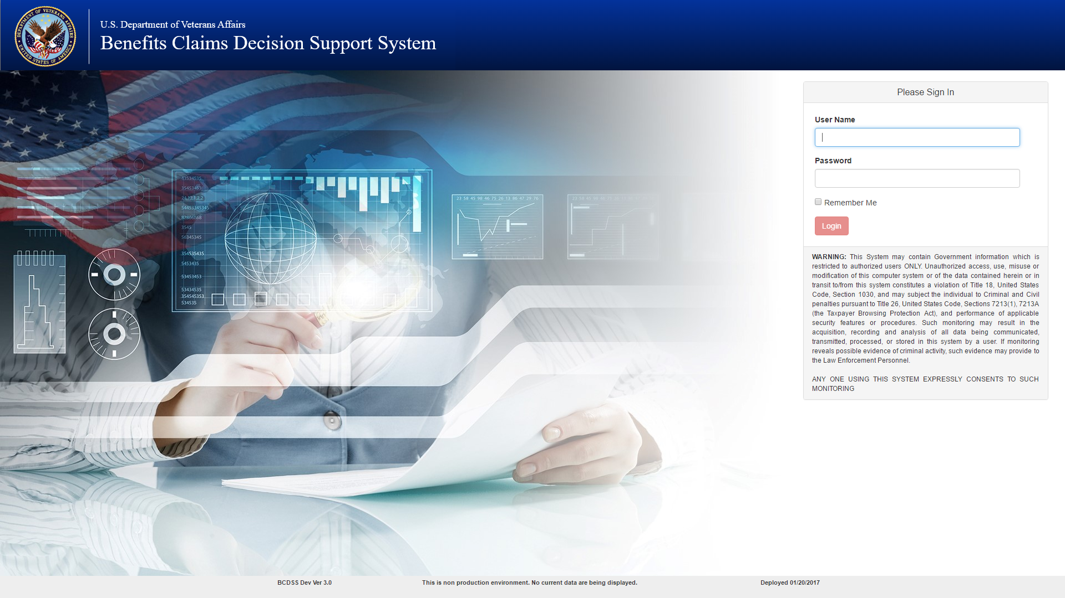

Figure : Login Page

# User Interface Features

## Top Panel

The top panel (see Figure 3 below) is open by default when you login to the application:

* Click the **Help** icon to view the user manual.
* **Sign Out** under the person iconto sign out of BCDSS and return to the login screen.
* Above the Grid are the following tabs that could be used to navigate and to use other features
  + **Claims–**This is the default display when you login
  + **Results**–Navigate to the Result search page to lookup the previously processed claims
  + **Process Claims**–This is the default display when you login, list of supplemental claims would be displayed under this tab
  + **Advanced Search–**A pop-up window shows up to filter the claims by claim Date range, Regional Office and Contention
  + **Clear**–this refreshes the page by clearing all the selected claims, and/or filtered claims.
  + **Search**–This would search the claim by all the column fields except date range (for with **Advanced Filter** need to be used)

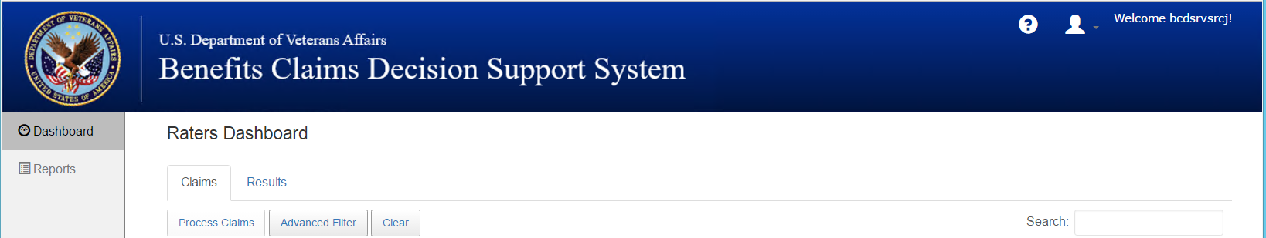

Figure : Top Panel

## Bottom Panel

The bottom flyout panel (see Figure 4) displays the build version on the bottom left and the last build date on the bottom right side.

The bottom left of the grid displays the claim available (numbers), and on the bottom right of the grid option to navigate to the different pages of the grid to view available claims.



Figure : Bottom Panel

## Left Panel

The left side of the dashboard (see Figure 5) is the navigation panel to navigate between Dashboard, and Report pages.

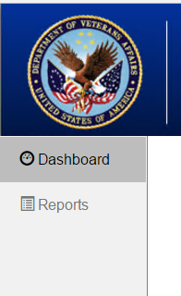

Figure : Left side Panel

# Home Screen (Dashboard)

The following section describe elements of the BCDSS user interface and a few special pop-up tools that appear based on the user-accessed functionality. The screen captures are examples for illustrative purposes and may differ slightly from the screens that you are viewing in the application.

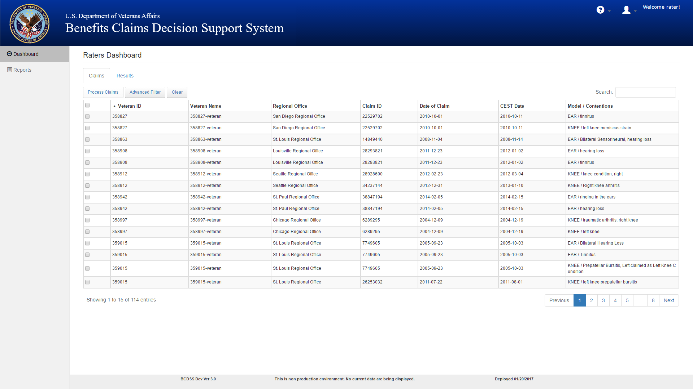

Figure : Home Screen (Dashboard)

## Selecting Claim(s) to Process the Model

The Claim Selection feature is used to select one or more claims from the retrieved claims. To perform this function, perform these steps from the Home screen:

1. Select the desired claim(s) from the retrieved historical claims list by checking the checkboxes on the left end of each claim.
2. Select **Process Claims** on the top left to process the claims.
3. Selecting Clear would reset the selections made on the Table.
4. Search the claims by entering the value in the **Search** box located on the top right of the grid.
5. By selecting the **Advanced Filter button on the top left of the table**, the claims could be further narrowed down by Date Range, Contention and Regional Office:
   1. In **Date From**, enter claims from date.
   2. In **Date To**, enter claims to date.  
      **Note**: Maximum of one year’s claims can be filtered.
   3. In **Regional Office**, select the regional office from the dropdown menu.
   4. In **Contention**, enter contention keywords.
   5. Click the **Filter** button to filter the claims by the entered criteria and skip to the Dashboard with the filtered claims list displayed.
6. Click **Cancel** button would cancel the search and skip to Dashboard unchanged. Results of the processed claim(s) are displayed in the table.
7. The Model output/results are shown in the **Model Results** column.

The actual manually Rated Evaluation is displayed in the **Rated Evaluation** column.

Comparisons of the **Model Results** and **Rated Evaluation** are shown in the **“RE/ME Match?”** column.

1. The Rater/Modeling Agent will be able to Agree/Disagree with the Model Evaluation in the **Agree/Disagree** column by selecting the appropriate decision from the dropdown menu.
2. Scroll to the lower right of the screen and click **Save** to save themodel results and its details.

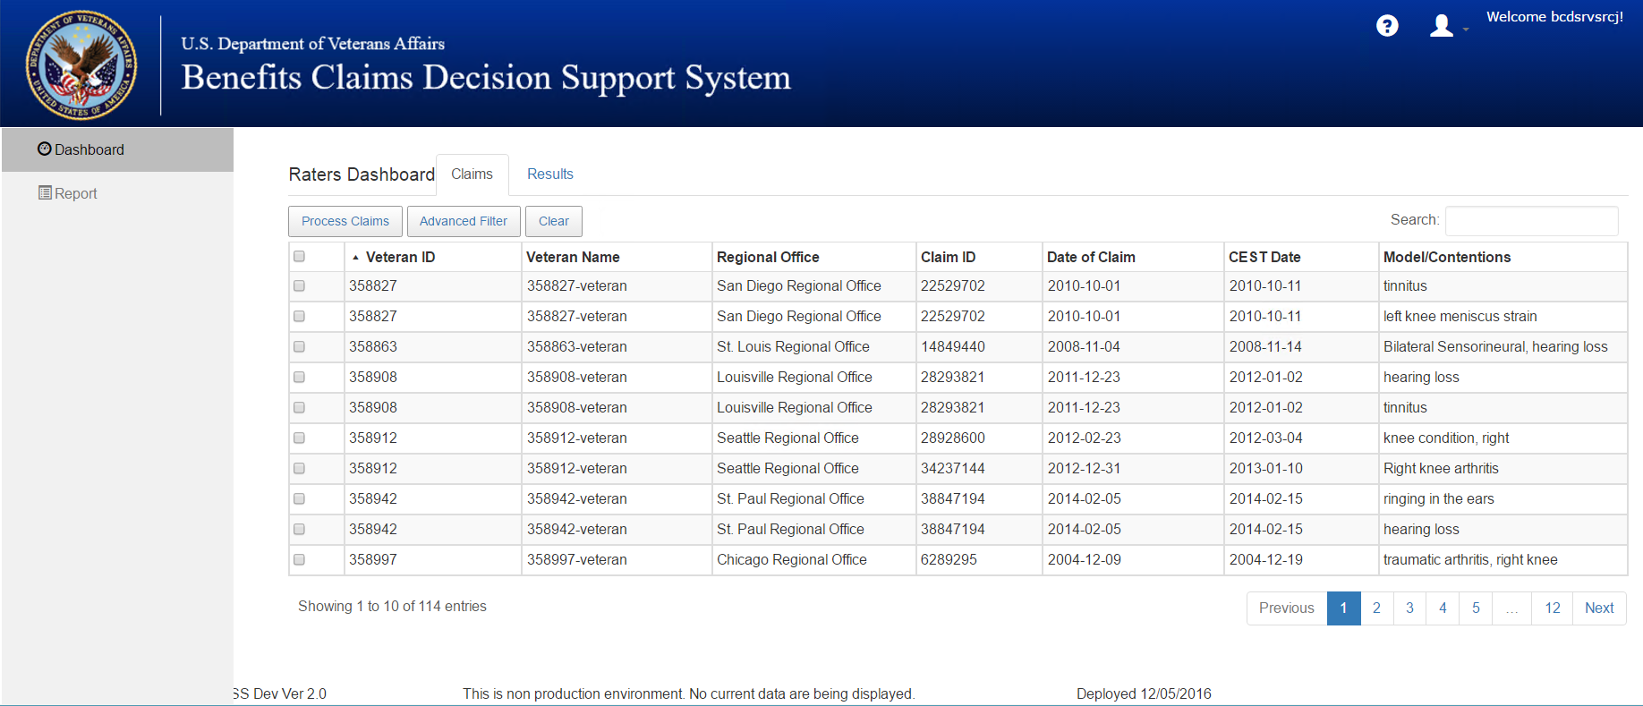

Figure : Search Claim(s)

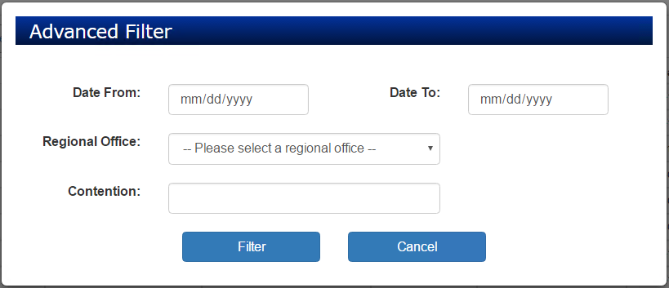

Figure : Advanced Filter

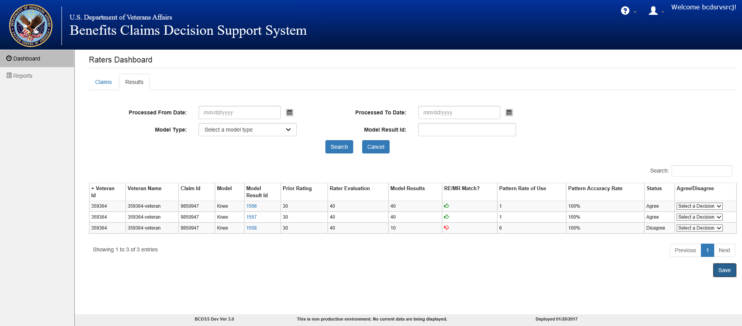

Figure : Results Page—Displaying Results

## Search Results to Review or Update Status

Search the results for the already processed claims. This provides the user the ability to search for the results and update the status.

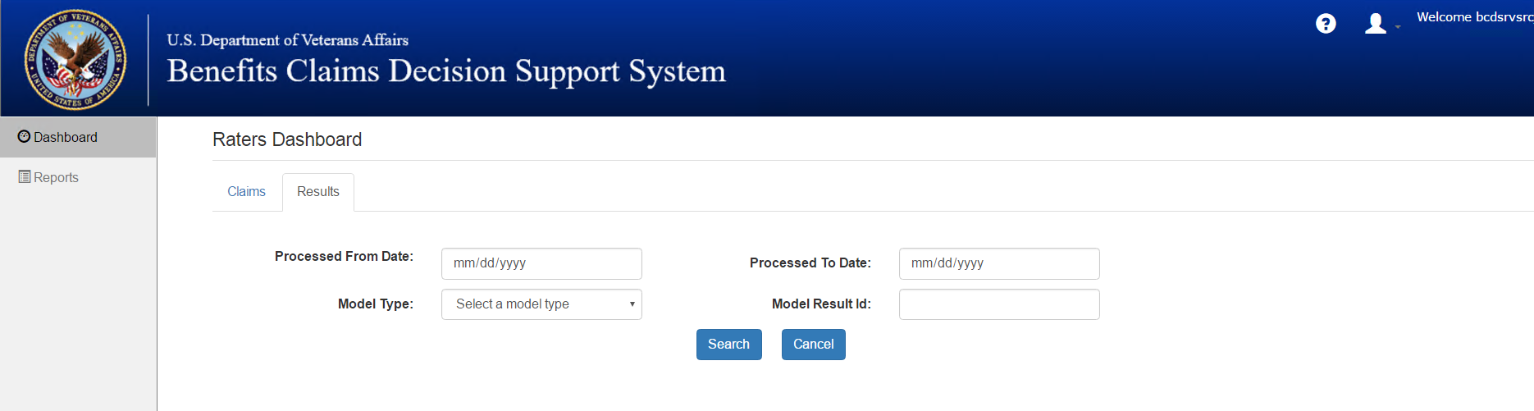

Figure : Raters Dashboard—Enter Criteria to Search Results

1. Click the **Result** tab on the top left of the table to search the results for a specific date range or model type.
2. Enter the **Processed From Date** and **Processed to Date**.
3. Select **Model Type** from the dropdown menu.
4. Click **Search** will display the results for the applied search criteria.
5. The **Agree/Disagree** determination can be updated in the column by selecting the appropriate decision from the **Agree/Disagree** column dropdown. The previous status will be displayed in the **Status** column.

**Note**: You could also use **Model Result ID** to retrieve the result of a specific claim.

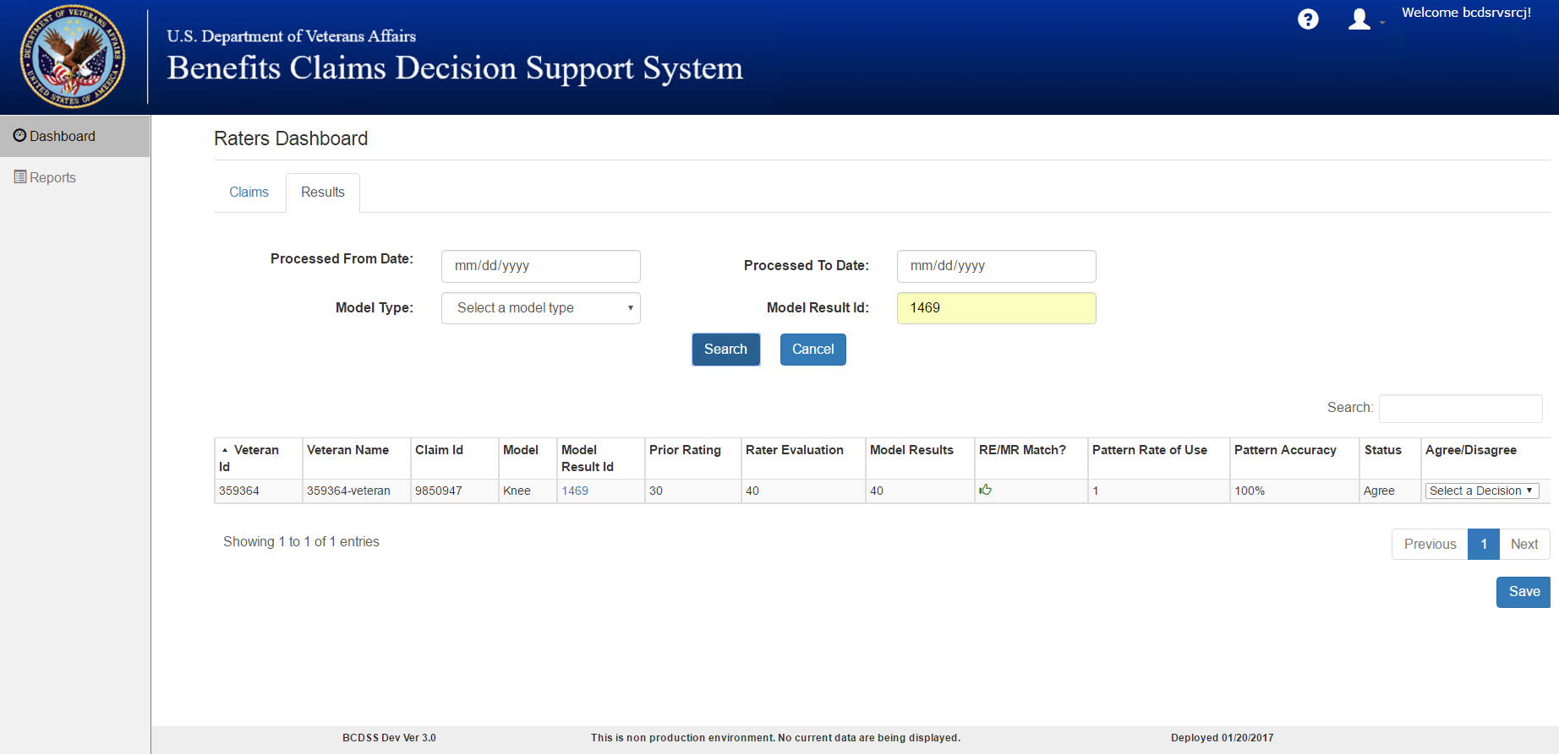

Figure : Raters Dashboard—Results

# Reports

## Detailed Analysis Report(s) for the Model Result(s)

Detailed Analysis Report can be generated from the Report tab by Rater and/or Modeling Agent. To generate the report the claims had to be processed before and saved.

1. Click the **Report** link on the right side panel as shown in Figure 12.

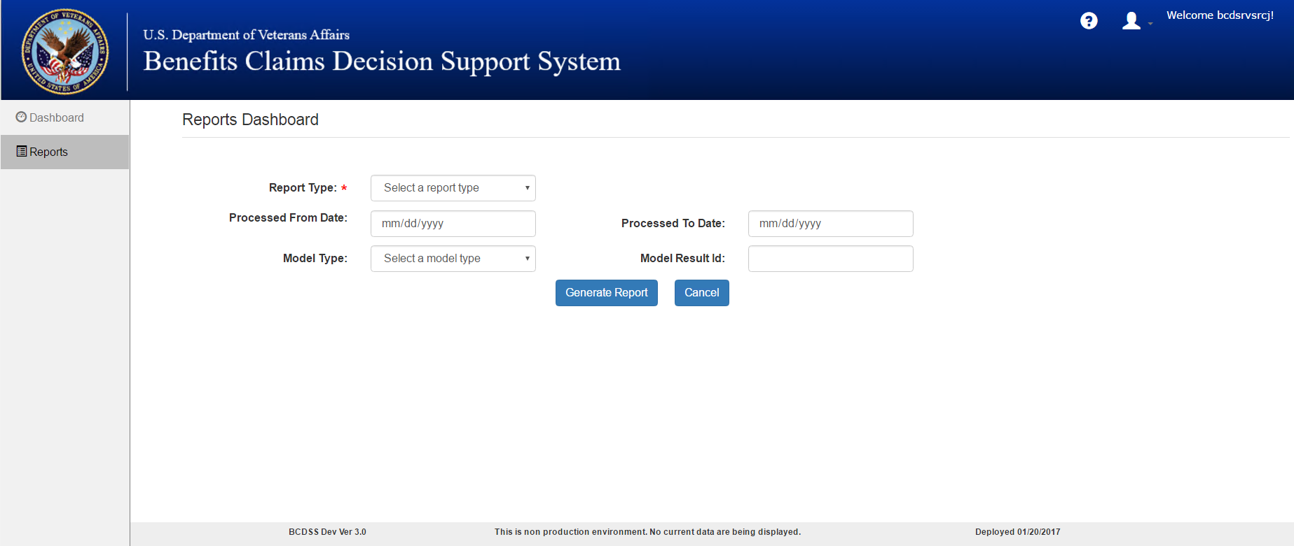

Figure : Reports Dashboard—Criteria to Generate Report

1. Select/Enter criteria for the report
2. Select **Report Type** as **Detailed** from the dropdown menu
3. Enter the **Model Result ID** to generate a specific report for the claim.

**Note**: If you do not know the Model result ID, you can enter the below criteria to get the report.

This returns more than one analysis report for all the claims processed during the date range entered. See Figure 13.

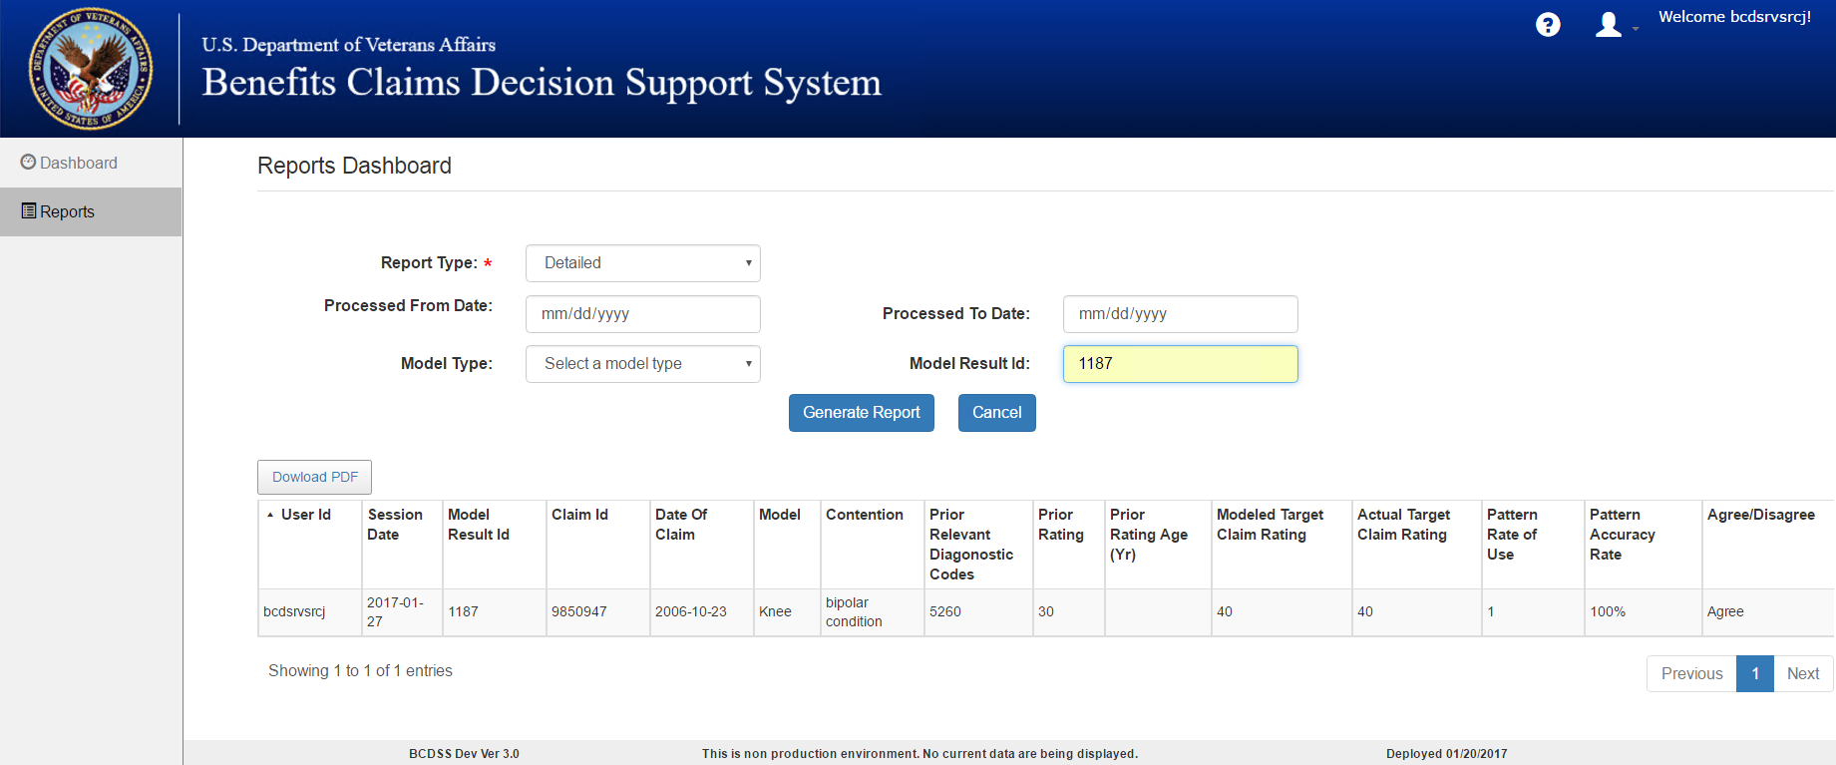

Figure : Reports Dashboard—Generate Report Based on the Model Result ID

To get the Detailed Analysis Report without a specific Model Result ID follow the below steps:

1. Select Report Type as **Detailed** from the dropdown menu
2. Enter claims **Processed From Date.**
3. Enter claims **Processed To Date.**
   1. **Note**: A maximum date-range of one year is allowed.
4. Select **Model Type** from the dropdown menu if you want to filter by Model Type.
5. Click on **Generate Report** and the report will be displayed on the same page.
6. Click on **Cancel** to reset the entered/selected report criteria.

**Note**: Once the report is displayed, you can download the displayed report by clicking **Download PDF** on top left of the grid. See Figure 14.

A downloaded PDF file can be saved on the local system. This PDF file can be uploaded to the eFolder or other system as needed.

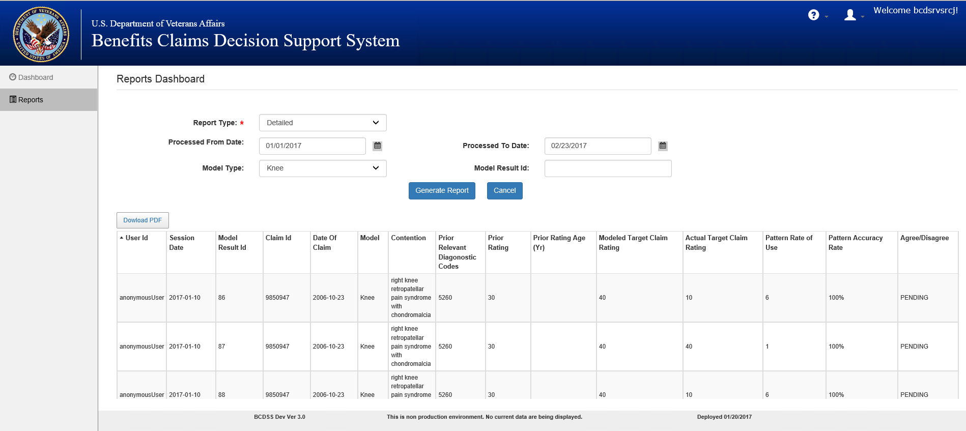

Figure : Reports Dashboard—Generate Report for a Date Range and/or Model Type

## Aggregate Analysis Report(s) for Processed Model

1. Select **Report Type** as **Aggregate** from the dropdown menu.

**Note**: Once **Aggregate** is selected from the dropdown menu, the remaining search criteria is disabled as the Aggregate report is for the entire claims processed in BCDSS.

1. Click **Generate Report** button to view the Aggregate Report of the claims processed.
2. Click **Cancel** to clear the search criteria entered (see Figure 15).

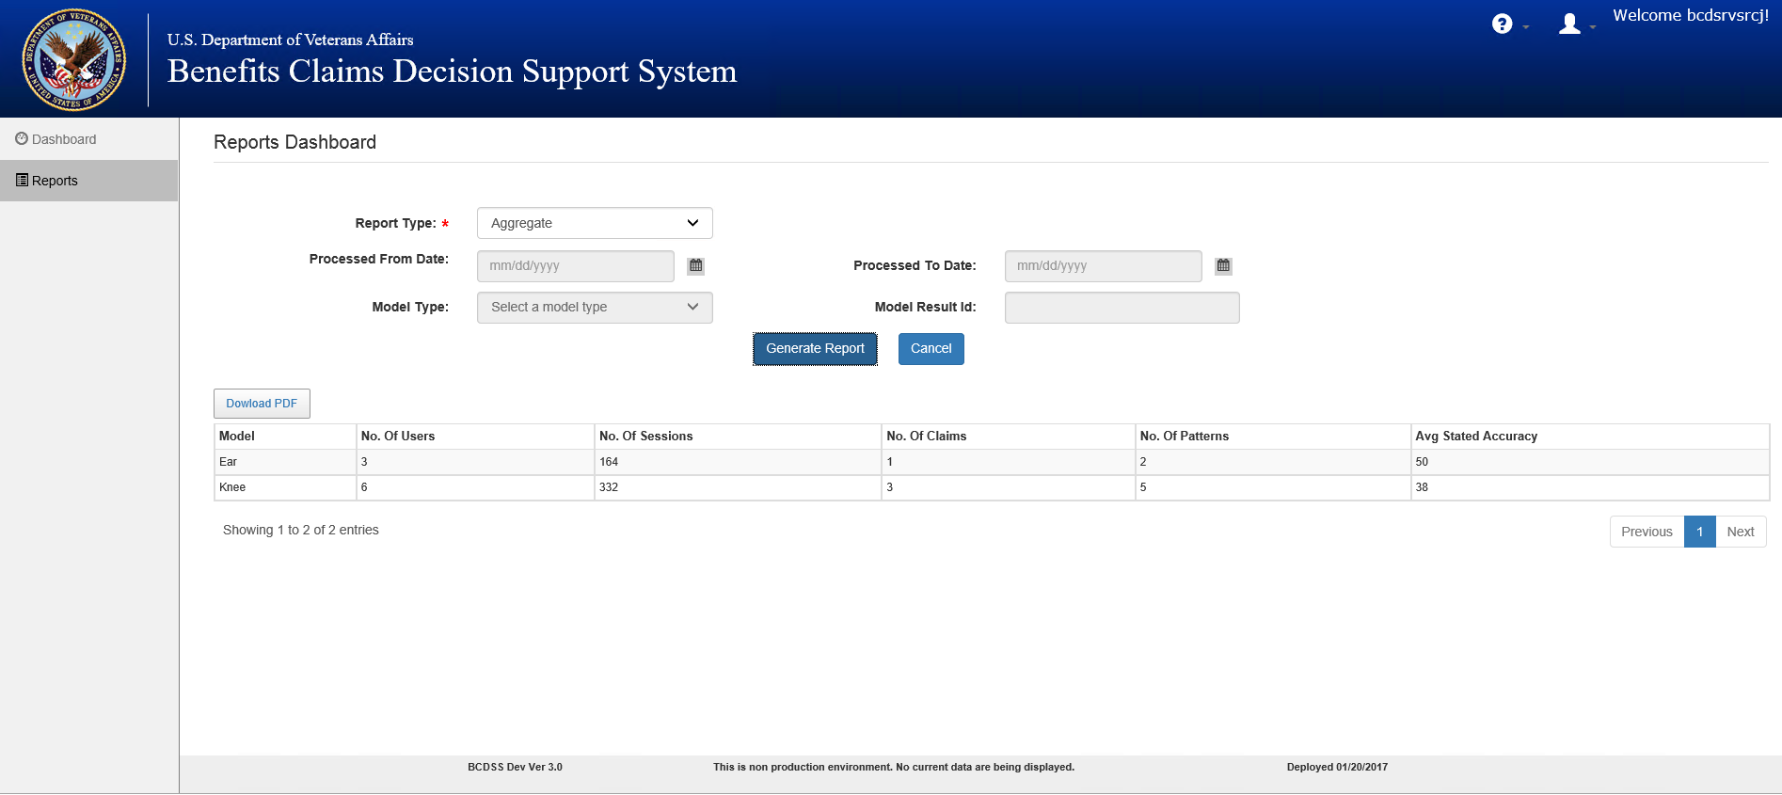

Figure : Reports Dashboard— Generate Aggregate Report

**Note**: Once the report is displayed, you can download the displayed report by clicking **Download PDF** on the top left of the grid.

A downloaded PDF file can be saved on the local system. This PDF file can be uploaded to the eFolder or other system as needed.

Table : Rater Report Fields

|  |  |
| --- | --- |
| **Field** | **Description** |
| User ID* |  |
| Session Date | The date the user applied the model to generate the specific result |
| Model Result ID | Unique identifier for the result generated by the model |
| Veteran ID | Unique Identifier for each Veteran/Customer |
| Claim ID | Unique Identifier for each claim filed by the Veteran/Customer |
| Date of Claim | The Date used to calculate when the Veteran filed the claim for benefit |
| Model | The name and version of the model applied by the user |
| Prior Relevant Diagnostic Codes | Diagnostic codes used in prior ratings |
| Prior Rating | The prior rating (or CDD) included in the matched pattern |
| Prior Rating Age (Yr.) | The elapsed period of time (in years) between the date of claim and the effective date of the prior rating |
| Modeled Target Claim Rating* |  |
| Actual Target Claim Rating* |  |
| Pattern Accuracy Rate | The number of times the matched pattern as resulted in the same rating as a fraction of the number of times it has occurred within the last 8 years |
| Pattern Rate of Use | The number of times the matched pattern has occurred within the last 8 years |

*Field description will be provided in an updated version of this document.

Table : Rater Report Displayed Fields

|  |  |
| --- | --- |
| **Field** | **Description** |
| Session Date | The date the user applied the model to generate the specific result |
| Model Used | The name and version of the model applied by the user |
| No. of Claims | The number of claims against which the model has been applied |
| Model Result ID | Unique identifier for the result generated by the model |
| Select | Check box to view the details of the selected item |

Table : Modeling Agent Report Fields

|  |  |
| --- | --- |
| **Field** | **Description** |
| No. of Sessions | The number of individual sessions in which users have applied the selected model |
| No. of Claims | The number of claims against which the model has been applied |
| Earliest Date* |  |
| Latest Date* |  |
| No. of Patterns | The number of patterns for the selected model as matched to target claims |
| Average Stated Accuracy | The average of the accuracy levels of the patterns matched to target claims |
| Actual Resulting Accuracy | The number of times the modeled rating equals actual rating as a % of the number of claims for which the model returned a result (matches) |
| % Agree | The number of times the RVSR/Rater agreed with the rating generated by the model as a % of the total number of claims for which the model returned a result (match) |
| Claims Rated | The total number of claims for which the model returned a result (Match) |
| % Throughput | The total number of claims for which the model returned a result (Match) as a % of the total number of against which the model was applied. |

*Field description will be provided in an updated version of this document.

Table : Modeling Agent Report Displayed Fields

|  |  |
| --- | --- |
| **Field** | **Description** |
| Session Date | The date the user applied the model to generate the specific result |
| User ID* |  |
| Run Type* |  |
| No. of Claims | The number of claims against which the model has been applied |
| Avg. Error Rate* |  |
| Model Result ID | Unique identifier for the result generated by the model |
| Select | Check box to view the details of the selected item |

*Field description will be provided in an updated version of this document.

# Administrator

## Administrator–Dashboard

Only an Administrator can access the **Administrator’s Dashboard,** which is displayed when a user logs in with Administrator credentials. The Administrator Dashboard allows the Administrator to manage users, i.e., Create Users, Edit Users, and Reset Password. To perform this function, follow these steps starting from the **Home** screen:

* 1. Administrator can create new users and assign roles by selecting Create User (see Figure 16 and Figure 17 for additional information).

1. Click **Create User** to display the User Editor screen (Figure 17) where the Administrator can fill in the listed details.
2. Click **Save** to save the new user.
3. Click **Cancel** to discard the changes.

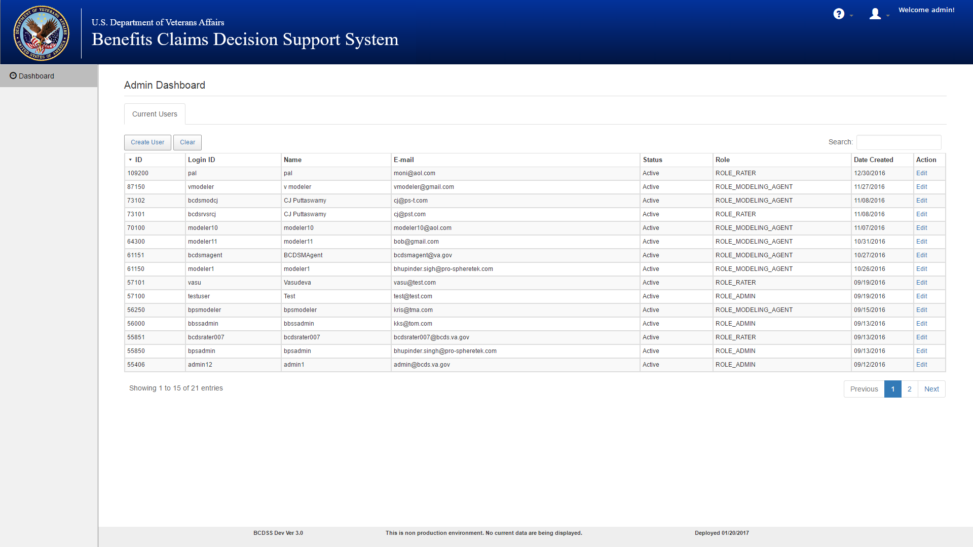

Figure 16: Administrator's Dashboard

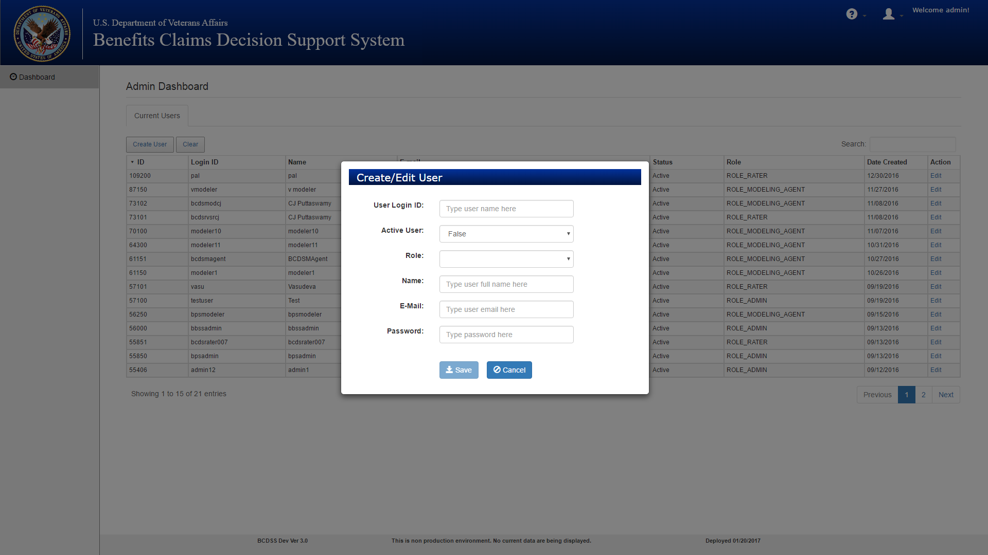

Figure : Add New User

## Administrator–Edit User

1. From the **Home** screen, select the user to edit by clicking **Edit** on the right side of the displayed user. The **User Editor** screen is displayed with the current details.
2. Update the details and click **Save** to update the user’s profile (see Figure 18).

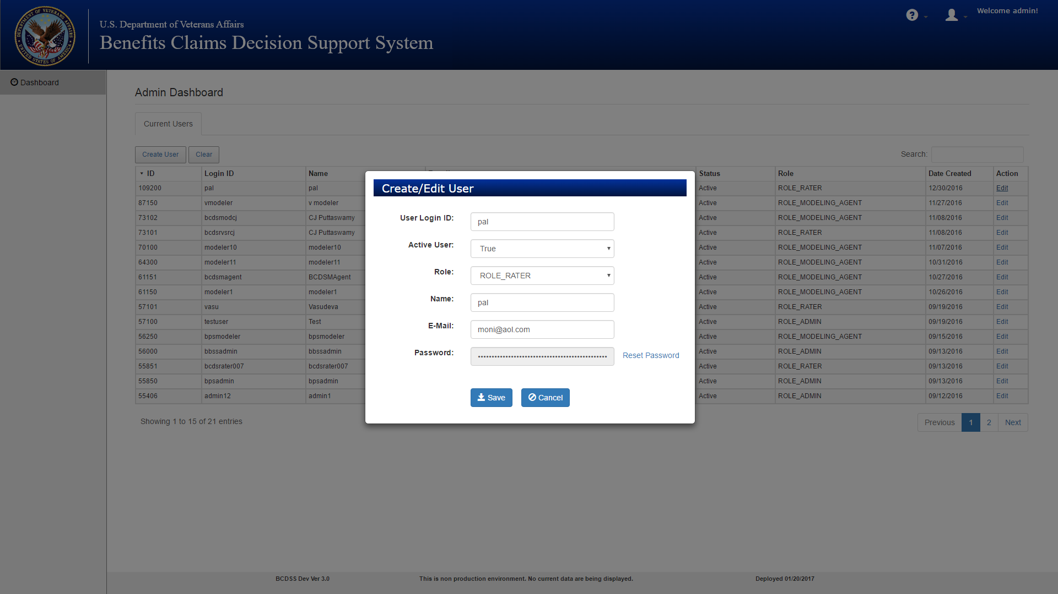

Figure : Edit User

## Administrator–Reset Password

Click **Reset Password** from the **User Editor** page to reset the selected user’s password.

# Approval Signatures

This section is used to document the approval of the User Guide Document. The review should be conducted face to face where signatures can be obtained during the review. If unable to conduct a face-to-face meeting, then it should be held via LiveMeeting and concurrence captured during the meeting. The Scribe should add /es/name by each position cited. Example provided below.

The Business Sponsor and Project Manager are required to sign.

__________________________________________________________________________

Business Sponsor Date

__________________________________________________________________________

Project Manager Date